Proposed Updates and Visuals
- User interaction is as follows
  - Select Model – do not refresh sheet if sheet is not blank, Refresh automatically if the sheet is blank
  - Sheet should be refreshed when user selects “Refresh Data”
  - In the manage Model option, a button needed to provide option to update selected dimension from the excel tab with the same name. E.g.“Measure” dimension will be updated from the excel tab with the same name when the button “Create from Tab” is selected. A tree view will be dispayed with the nodes and leafs highlighted in a visually pleasing view. The dimension member for accounts will have a “Plus” or “Minus” or “ignore” sign to show if its value is added or subtracted when aggregated. This field will be updated from the ConsolOp column in the dimension table. The member formula will also be picked up from the Formula column. This is relevant for the prototype for Measure and Time dimensions

  - Remove the add-ins tab – see highlighted in below
  - Show a cube as the icon for the Select Model option
  - Show icons for all actions that are missing icons e.g. Drill-down.
  - Change Swap Row/Col to Swap to Row/Col
  - Screen not rendering in readable proportions
  - Remove version # from MyOlap add-in menu item
  - Show an Info group with

Active Model:Sales

Add-in version: v2.2
- Remove Export PDF option, instead, if possible provide Print PDF option to export Dimension Tree view for selected dimension. This will be helpful to review parent-child format in the Tabs in hierarchical trees
Sample Measure Dimension Tree Preview in Excel shown below:

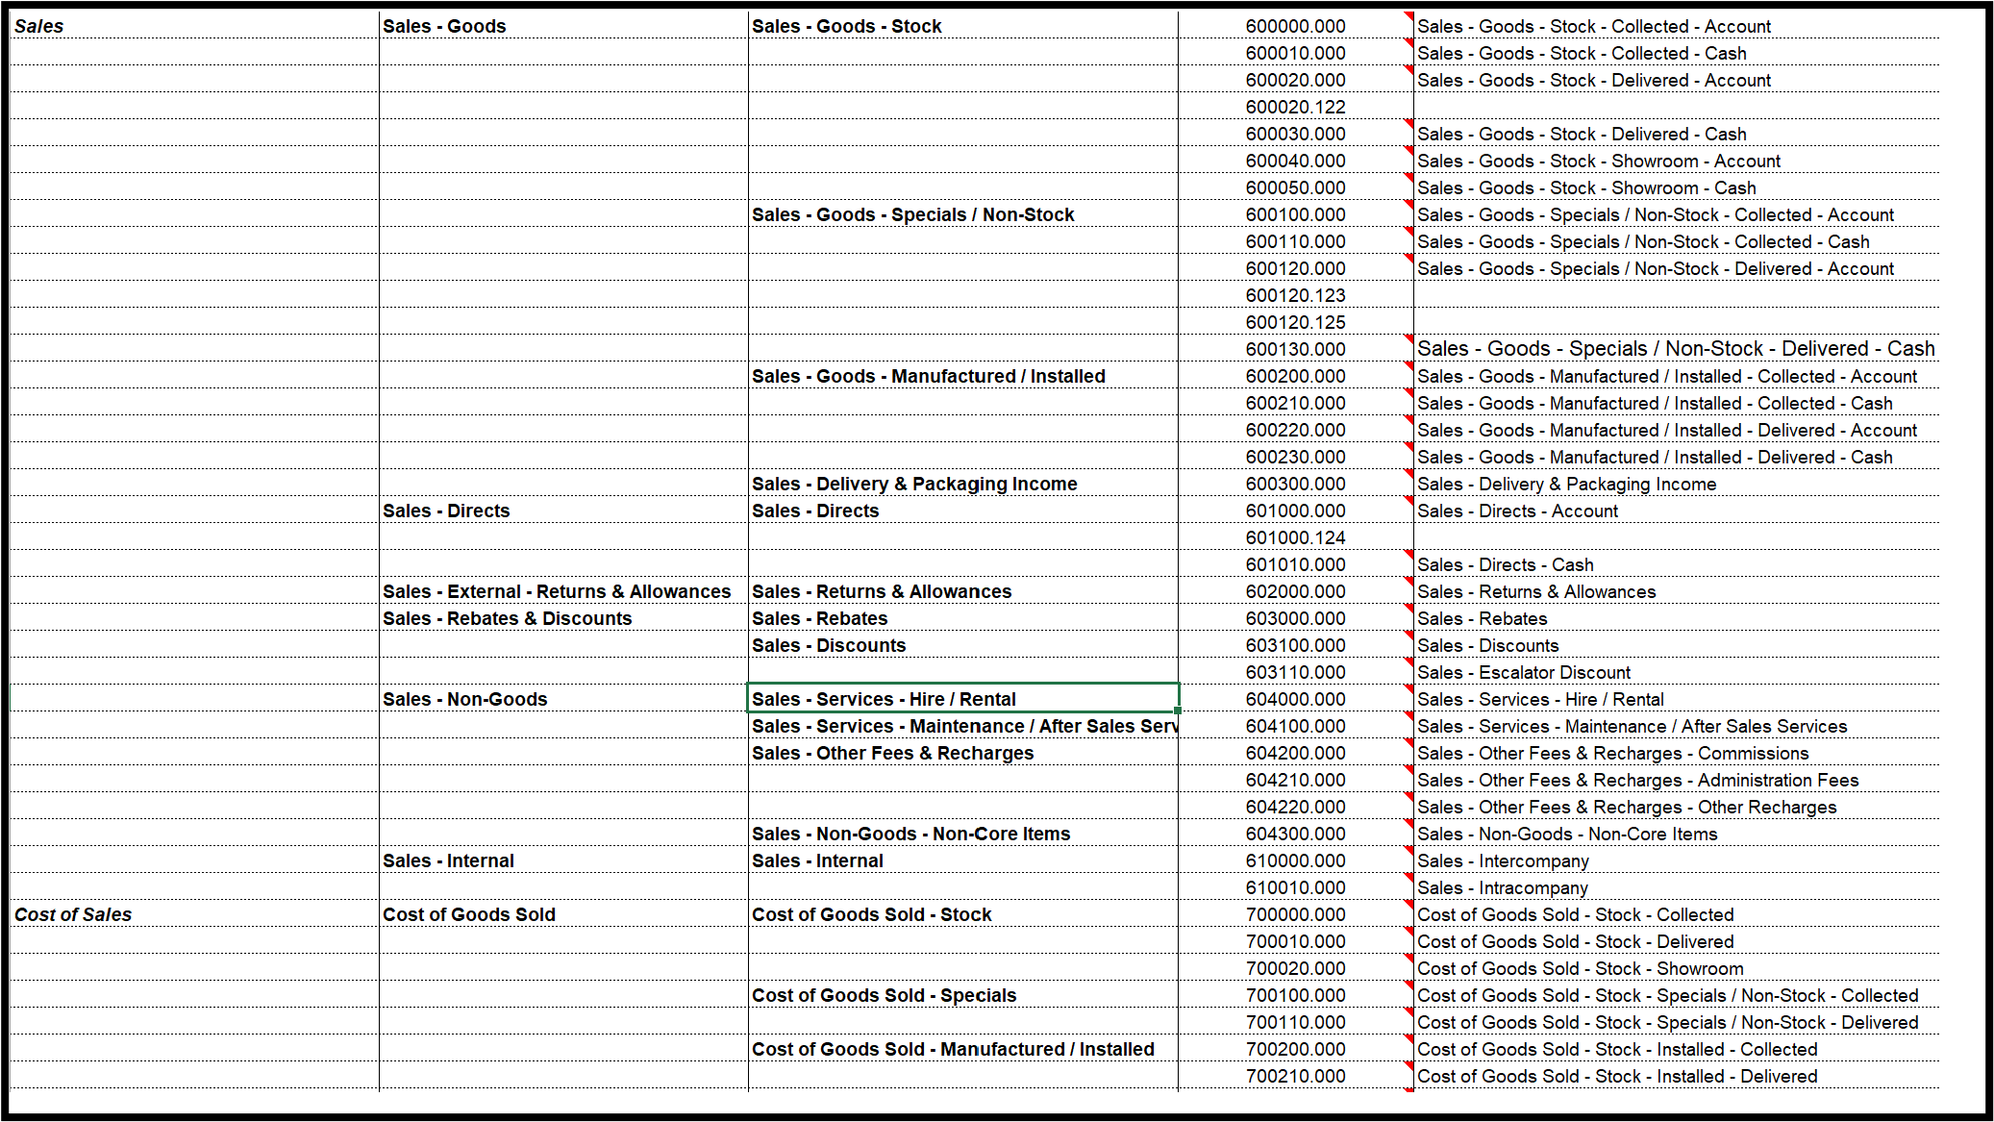

- Please provide a Clear Data option above Load Data: Provide option to Select View and Year or Clear All Data. E.g. View: Budget, Year: FY26
- The <new model> button should create the default dimensions in this order: automatically

Measure, Time, Year, View and Version
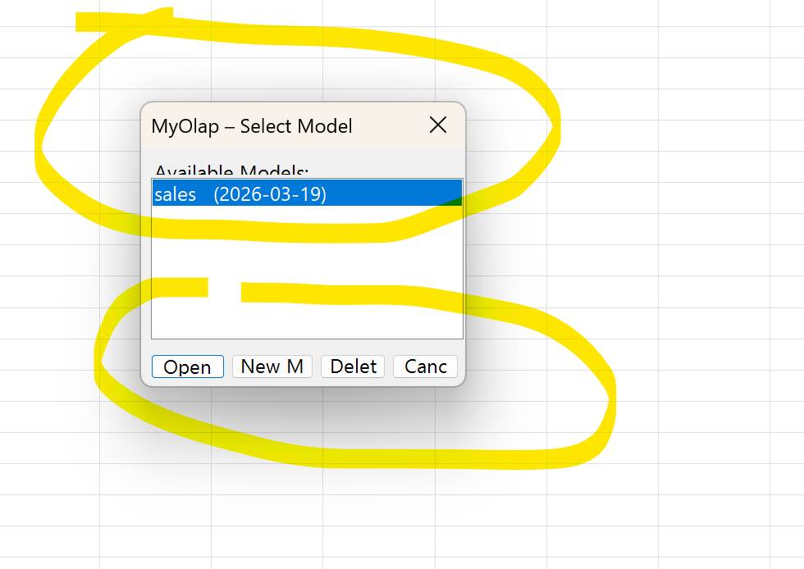

- Default View when a user selects a MyOlap model should be as below
  - Measures in the Rows, Time in the Column
  - Other dimensions (BU, Product, Customer, Version, Year and View as Top Line row 1)
  - Member selection window should show the tree structure and appear as below or better

